**UNIT – 2: Big Data Technologies: Hadoop’s Parallel World – Data discovery – Open source technology for BigData Analytics – cloud and Big Data –Predictive Analytics – Mobile Business Intelligence and Big Data**

1. **Big Data Technologies: Hadoop’s Parallel World:**

Hadoop is an Apache open source framework written in java that allows distributed processing of large datasets across clusters of computers using simple programming models. The Hadoop framework application works in an environment that provides distributed storage and computation across clusters of computers. Hadoop is designed to scale up from single server to thousands of machines, each offering local computation and storage.

***Hadoop Architecture:*** At its core, Hadoop has two major layers namely −

1. Processing/Computation layer (MapReduce), and
2. Storage layer (Hadoop Distributed File System).

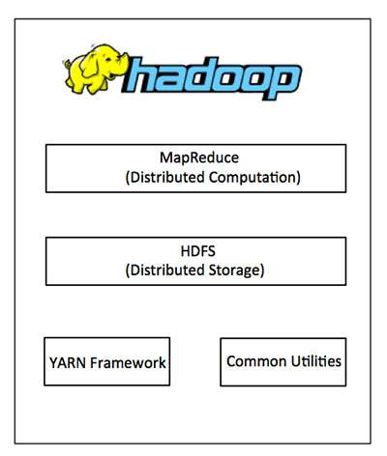

1. ***MapReduce:*** MapReduce is a parallel programming model for writing distributed applications devised at Google for efficient processing of large amounts of data (multi-terabyte data-sets), on large clusters (thousands of nodes) of commodity hardware in a reliable, fault-tolerant manner. The MapReduce program runs on Hadoop which is an Apache open-source framework.
2. ***Hadoop Distributed File System:*** The Hadoop Distributed File System (HDFS) is based on the Google File System (GFS) and provides a distributed file system that is designed to run on commodity hardware. It has many similarities with existing distributed file systems. However, the differences from other distributed file systems are significant. It is highly fault-tolerant and is designed to be deployed on low-cost hardware. It provides high throughput access to application data and is suitable for applications having large datasets.

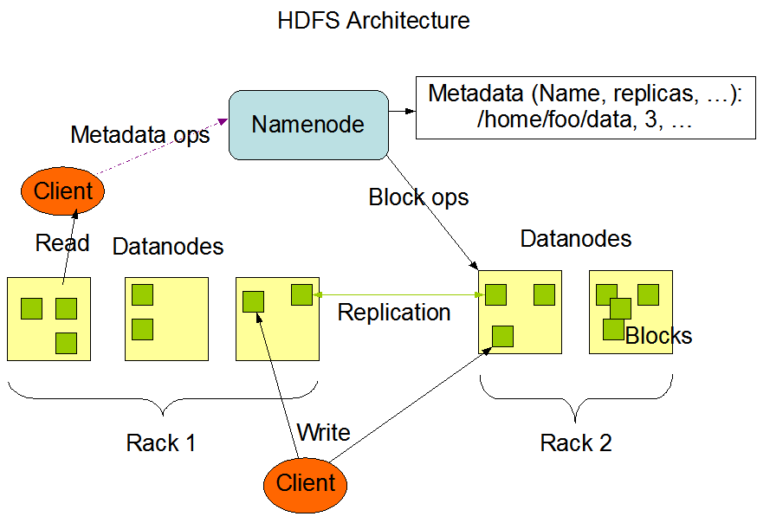

Apart from the above-mentioned two core components, Hadoop framework also includes the following two

modules −

1. Hadoop Common − These are Java libraries and utilities required by other Hadoop modules.
2. Hadoop YARN − This is a framework for job scheduling and cluster resource management.

***How Does Hadoop Work?***

It is quite expensive to build bigger servers with heavy configurations that handle large scale processing, but as an alternative, you can tie together many commodity computers with single-CPU, as a single functional distributed system and practically, the clustered machines can read the dataset in parallel and provide a much higher throughput. Moreover, it is cheaper than one high-end server. So this is the first motivational factor behind using Hadoop that it runs across clustered and low-cost machines.

Hadoop runs code across a cluster of computers. This process includes the following core tasks that Hadoop performs −

* Data is initially divided into directories and files. Files are divided into uniform sized blocks of 128M and 64M (preferably 128M).
* These files are then distributed across various cluster nodes for further processing.
* HDFS, being on top of the local file system, supervises the processing.
* Blocks are replicated for handling hardware failure.
* Checking that the code was executed successfully.
* Performing the sort that takes place between the map and reduce stages.
* Sending the sorted data to a certain computer.
* Writing the debugging logs for each job.

***Advantages of Hadoop:***

* Hadoop framework allows the user to quickly write and test distributed systems. It is efficient, and it automatic distributes the data and work across the machines and in turn, utilizes the underlying parallelism of the CPU cores.
* Hadoop does not rely on hardware to provide Fault-Tolerance and High Availability (FTHA), rather Hadoop library itself has been designed to detect and handle failures at the application layer.
* Servers can be added or removed from the cluster dynamically and Hadoop continues to operate without interruption.
* Another big advantage of Hadoop is that apart from being open source, it is compatible on all the platforms since it is Java based.

1. **Data discovery:**

**Data Discovery** involves the collection and evaluation of data from various sources and is often used to understand trends and patterns in the data. It requires a progression of steps that organizations can use as a framework to understand their data. Data discovery, usually associated with [***business intelligence***](https://www.tibco.com/reference-center/what-is-business-intelligence)***(***[***BI***](https://www.tibco.com/reference-center/what-is-business-intelligence)***),*** helps inform business decisions by bringing together disparate, siloed data sources to be analyzed. Having mounds of data is useless unless you find a way to extract insights from it. The data discovery process includes connecting multiple data sources, cleansing and preparing the data, sharing the data throughout the organization, and performing analysis to gain insights into business processes.

Today, nearly all businesses collect huge amounts of data on their customers, markets, suppliers, production processes, and more. Data flows in from online and traditional transactions systems, sensors, social media, mobile devices, and other diverse sources. As a result, decision makers are drowning in data but starving for insights. Insights are hidden within that data.

Data exploration and visual analytics is one approach that business data analysts use to uncover and investigate hidden but potentially useful insights in data. It is a methodology for digging into data looking for interesting relationships, trends, patterns, and anomalies requiring further exploration. Exploration and visual analytics enables the use of technology assisted analytical and pattern recognition software for visualization and drill-downs to turn data into knowledge and understanding.

Data discovery offers businesses a way to make their data clean, easily understandable, and user-friendly. A comprehensive solution should be able to be used by all members of the business. The main benefit of data discovery is the actionable insights that are uncovered in the data. These insights help users spot valuable opportunities before competitors without having to consult the IT organization. Visual data discovery can enhance this value, allowing line of business workers to find answers faster.

Today, companies are finding that the use of artificial intelligence (AI) is greatly enhancing the data discovery process. This process is also referred to as smart data discovery. In smart data discovery, AI can automatically discover data relationships and accelerate a company’s analyses with AI-powered recommendations. The underlying AI suggestion engine uses sophisticated AI algorithms that run against any type of data without the user being aware that processing is happening in the background. The AI engine identifies potential relationships such as correlations by employing trained learning algorithms. Leading analytics platforms utilizing AI offer recommended visualizations of related variables that users can choose to explore further.

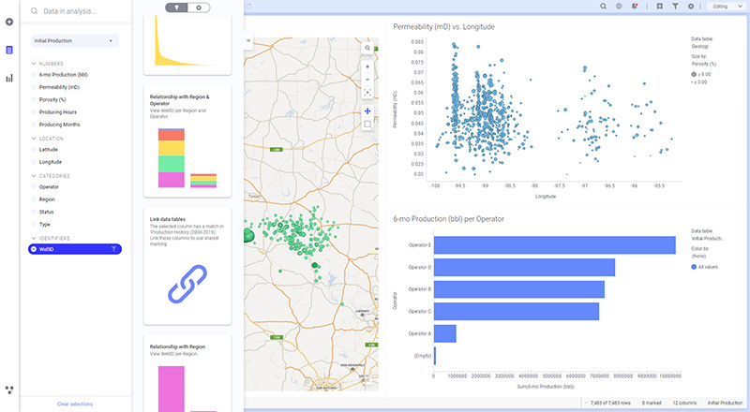

There are several exciting directions for innovation in the area of AI-powered analytics including:

* AI techniques can be used to suggest data preparation steps such as normalization, missing data handling, string pattern recognitions, and others.
* Algorithms can be used to identify and draw attention to particular patterns or outliers in the data for groups of related variables.
* Time series analysis has distinct needs and techniques for pattern recognition, anomaly detection, and series relationships discovery.
* Behavioral data of expert users can be collected, analyzed, and used to influence recommended analysis actions.

AI suggestion engines and recommendations are increasingly used to augment analytics on an ever-expanding space of problems. This combination of human understanding with machine tirelessness enables business professionals to rapidly discover important relationships across vast amounts of data in time to take action.

***Solving Business Problems with Data Discovery***

Analysts are tasked with discovering insights in the massive amounts of data that businesses collect. Because it brings in data from so many different sources, data discovery enables businesses to use data in innovative ways. It helps users explore data in new and different ways and to find insights that were not apparent prior to data discovery. And, once new trends or patterns are made, data discovery makes it easy for users to drill down into the variables and come up with new questions and insights.

These insights can include identifying customer problems such as the following:

* Unexpected customer churn
* Customer relationship and management problems
* Subtle product issues such as returns and failures
* Price leakages due to excessive discounting
* Promotional failures
* Lost market share due to competitive actions such as aggressive pricing or a new product

Data discovery is enabling companies to capture a 360-degree view of their customers by compiling and assessing customer behavioral, transactional, and sentiment data across the many channels customers use to interact with companies.

Data discovery is invaluable in helping decision makers detect early warning signs about customer dissatisfaction. Data discovery helps business leaders gain a more thorough understanding of how customers view the company.

Text, sentiment, social, and speech analytics can be used to identify what customers are saying about your company across a variety of interactions, including social media comments and contact center interactions. Key word searches against customer sentiment can help business leaders identify where potential product or service problems may be coming to the fore with multiple customers.

Data discovery tools also offer banks myriad opportunities to learn more about their customers and act on these insights. For instance, data discovery tools can help bankers determine which products a particular customer is using (e.g., checking, savings) and then determine based on that customer’s income, lifecycle status, and other factors whether she might be a good candidate for a cross-sell or upsell offer (e.g., certificate of deposit).

With customer churn so high in financial services, bankers can also use data analysis and data discovery tools to determine the primary causes of customer defection among certain groups of customers and also to spot the warning signs when a customer is about to jump ship. Undetected and unaddressed, these problems can seriously undermine any business. Hence the urgency to find insights in the data and take action. With the right insights, companies can focus their efforts where they are needed to retain and delight customers rather than simply throwing customer-enticing tactics against the wall and see what sticks. Data discovery puts the power of big data into the hands of the everyday business user giving them the information that they need to make data-driven business decisions.

1. **Open source technology for BigData Analytics:**

Open-source big data analytics refers to the use of open-source software and tools for analyzing huge quantities of

data in order to gather relevant and actionable information that an organization can use in order to further its business goals. The biggest player in open-source big data analytics is Apache's Hadoop – it is the most widely used software library for processing enormous data sets across a cluster of computers using a distributed process for parallelism.

Open-source big data analytics makes use of open-source software and tools in order to execute big data analytics by either using an entire software platform or various open-source tools for different tasks in the process of data analytics. Apache Hadoop is the most well-known system for big data analytics, but other components are required before a real analytics system can be put together.

Hadoop is the open-source implementation of the MapReduce algorithm pioneered by Google and Yahoo, so it is the basis of most analytics systems today. Many big data analytics tools make use of open source, including robust database systems such as the open-source MongoDB, a sophisticated and scalable NoSQL database very suited for big data applications, as well as others.

Open-source big data analytics services encompass:

* Data collection system
* Control center for administering and monitoring clusters
* Machine learning and data mining library
* Application coordination service
* Compute engine
* Execution framework

# *Top 10 Open-source Big Data Tools:*

* **Hadoop**: analyzes large data sets, as the platform can send data to different servers.
* **Apache Spark:** It fills the gaps of Hadoop when it comes to data processing. It is also used for data analysis over other types of programs due to its ability to store large computations in memory.
* **Apache Cassandra:** It processes structured data sets.
* **MongoDB:** It is a document-oriented database is an ideal choice for businesses that need fast and real-time data for instant decisions.
* **HPCC (High-Performance Computing Cluster):** It is the competitor of Hadoop in the big data market. It is one of the open-source big data tools under the Apache 2.0 license. It delivers on a single platform, a single architecture, and a single programming language for data processing.
* **Apache Storm:** It is a free big data open-source computation system. It offers a distributed, real-time, fault-tolerant processing system.
* **Apache SAMOA (Scalable Advanced Massive Online Analysis):** It is used for mining big data streams with a special emphasis on machine learning enablement. It supports the ***Write Once Run Anywhere (WORA)*** architecture that allows seamless integration of multiple distributed stream processing engines into the framework.
* **Atlas.ti:** With this tool, we can access all available platforms from one place. It can be utilized for hybrid techniques and qualitative data analysis in academia, business, and user experience research.
* **Stats iQ:** It is used to automatically selects statistical tests. It is a large data tool that can quickly examine any data, and with Statwing, you can quickly make charts, discover relationships, and tidy up data.
* **CouchDB:** It uses JSON documents that can be browsed online or queried using JavaScript to store information. It enables fault-tolerant storage and distributed scaling.

1. **Cloud and Big Data:**
2. **Big Data:** Big data refers to the data which is huge in size and also increasing rapidly with respect to time. Big data includes structured data, unstructured data as well as semi-structured data. Big data can not be stored and processed in traditional data management tools it needs specialized big data management tools. It refers to complex and large data sets having 5 V’s volume, velocity, Veracity, Value and variety information assets. It includes data storage, data analysis, data mining and data visualization. Examples of the sources where big data is generated includes social media data, e-commerce data, weather station data, IoT Sensor data etc.

***Characteristics of Big Data:***

* Variety of Big data – Structured, unstructured, and semi structured data
* Velocity of Big data – Speed of data generation
* Volume of Big data – Huge volumes of data that is being generated
* Value of Big data – Extracting useful information and making it valuable
* Variability of Big data – Inconsistency which can be shown by the data at times.

***Advantages of Big Data:***

* Cost Savings
* Better decision-making
* Better Sales insights
* Increased Productivity
* Improved customer service.

***Disadvantages of Big Data:***

* Incompatible tools
* Security and Privacy Concerns
* Need for cultural change
* Rapid change in technology
* Specific hardware needs.

1. **Cloud Computing:** Cloud computing refers to the on demand availability of computing resources over internet. These resources includes servers, storage, databases, software, analytics, networking and intelligence over the Internet and all these resources can be used as per requirement of the customer. In cloud computing customers have to pay as per use. It is very flexible and can be resources can be scaled easily depending upon the requirement. Instead of buying any IT resources physically, all resources can be availed depending on the requirement from the cloud vendors. Cloud computing has three service models i.e Infrastructure as a Service (IaaS), Platform as a Service (PaaS) and Software as a Service (SaaS). Examples of cloud computing vendors who provides cloud computing services are Amazon Web Service (AWS), Microsoft Azure, Google Cloud Platform, IBM Cloud Services etc.

***Characteristics of Cloud Computing:***

* On-Demand availability
* Accessible through a network
* Elastic Scalability
* Pay as you go model
* Multi-tenancy and resource pooling.

***Advantages of Cloud Computing:***

* Back-up and restore data
* Improved collaboration
* Excellent accessibility
* Low maintenance cost
* On-Demand Self-service.

***Disadvantages of Cloud Computing:***

* Vendor lock-in
* Limited Control
* Security Concern
* Downtime due to various reason
* Requires good Internet connectivity.

**Difference between Big Data and Cloud Computing:**

|  |  |  |
| --- | --- | --- |
| **S. No.** | **BIG DATA** | **CLOUD COMPUTING** |
| 1 | Big data refers to the data which is huge in size and also increasing rapidly with respect to time. | Cloud computing refers to the on demand availability of computing resources over internet. |
| 2 | Big data includes structured data, unstructured data as well as semi-structured data. | Cloud Computing Services includes Infrastructure as a Service (IaaS), Platform as a Service (PaaS) and Software as a Service (SaaS). |
| 3 | Volume of data, Velocity of data, Variety of data, Veracity of data, and Value of data are considered as the 5 most important characteristics of Big data. | On-Demand availability of IT resources, broad network access, resource pooling, elasticity and measured service are considered as the main characteristics of cloud computing. |
| 4 | The purpose of big data is to organizing the large volume of data and extracting the useful information from it and using that information for the improvement of business. | The purpose of cloud computing is to store and process data in cloud or availing remote IT services without physically installing any IT resources. |
| 5 | Distributed computing is used for analyzing the data and extracting the useful information. | Internet is used to get the cloud based services from different cloud vendors. |
| 6 | Big data management allows centralized platform, provision for backup and recovery and low maintenance cost. | Cloud computing services are cost effective, scalable and robust. |
| 7 | Some of the challenges of big data are variety of data, data storage and integration, data processing and resource management. | Some of the challenges of cloud computing are availability, transformation, security concern, charging model. |
| 8 | Big data refers to huge volume of data, its management, and useful information extraction. | Cloud computing refers to remote IT resources and different internet service models. |
| 9 | Big data is used to describe huge volume of data and information. | Cloud computing is used to store data and information on remote servers and also processing the data using remote infrastructure. |
| 10 | Some of the sources where big data is generated includes social media data, e-commerce data, weather station data, IoT Sensor data etc. | Some of the cloud computing vendors who provides cloud computing services are Amazon Web Service (AWS), Microsoft Azure, Google Cloud Platform, IBM Cloud Services etc. |

1. **Predictive Analytics:**

Big Data is frequently used to discuss Predictive Analytics. Predictive Analytics isn’t a black-and-white notion or a stand-alone component of today’s database management systems. It’s, rather, a collection of data analysis tools and statistical methodologies. Thus, Big Data and business intelligence (BI) combine to bring about predictive analytics.

Predictive Analytics involves accumulating and analyzing historical data in order to predict future results. Connecting the dots between different departments, business processes, and forms of Big Data is made possible by combining multiple datasets. Examples of these future results include trends (“where a particular stock is likely to move?”) and behavior traits (“what a particular customer is likely to purchase?”). To put it another way, Predictive Analytics is used to predict what will happen in a particular situation.

Many forward-thinking businesses, such as Google and Amazon, have recognized the value of Big Data Predictive Analytics in achieving a competitive advantage. These methods allow for the discovery of patterns and the improvement of optimization algorithms, among other things.

As Big Data technology evolves, businesses are turning to Predictive Analytics to help them enhance consumer engagement, streamline operations, and cut operational costs. The combination of real-time Big Data streams with Predictive Analytics— also known as “never-ending processing”— has the potential to give businesses a significant competitive advantage. Big Data Predictive Analytics is one way to use all of that data, obtain actionable new insights, and remain ahead of the competition

***Examples of Predictive Analytics***

* Customer Service
* Higher Education
* Insurance
* Supply Chain
* Software Testing

***Predictive Analytics Techniques***

* Decision Trees
* Neural Networks
* Text Analytics
* Regression Model

***Predictive Analytics in Conjunction with Big Data: How They Work?***

The heart of Predictive Analytics is that it is possible to ‘model’ most things. Underlying this idea is the notion that, between the data parameters, there is a cause and effect relationship, i.e., that as some data parameters change (cause), other data parameters will change in response (effect). In a nutshell, the following is a step-by-step procedure for using Predictive Analytics in businesses:

* Massive amounts of historical data are gathered or compiled.
* Certain statistical procedures, such as regression models, are used to analyze the data.
* The results of these assessments are then used to make forecasts about potential future events.
* These future predictions can then be used to help with decision-making, business process improvement, waste reduction, and more.

The final step would be to review the impact of Predictive Analytics on the process under consideration.

***Big Data Predictive Analytics Processing:*** Predictive Analytics uses Big Data to find meaningful patterns to forecast future events, and evaluate the attractiveness of different solutions. Predictive Analytics can be used to analyze any form of unknown data from the past, present, or future. Using Big Data insights, Predictive Analytics gives businesses intelligence about the future

***Comparisons between Big Data and Predictive Analytics:***

The following are the top Big Data Predictive Analytics comparisons:

|  |  |
| --- | --- |
| **Big** **Data** | **Predictive** **Analytics** |
| Big Data is concerned with the purification and interpretation of large amounts of data and can be applied to many business activities. | Predictive Analytics is a technique for predicting business and market events. |
| Big Data engines include built-in machine learning libraries, but integrating AI is still an R&D work for Data Engineers. | It deals with a platform based on mathematical calculations and probability. |
| The amount of data and the speed with which it is processed are enormous. It’s not recommended to use Big Data platforms for small amounts of data because their performance is exponential. | The amount of data and the speed with which it is processed are both on the medium side. In terms of models and algorithms, very large and very small data sets can contribute to inaccurate predictions and discoveries. |
| Big Data comes with D3.js, Tableau, infogram, and other backend technology imports for Dashboards and Visualizations. | Predictive Analytics tools have built-in reporting integrations, such as Microsoft BI tools. So there’s no need to get it from the source or a third-party seller. |
| The level of advancement for Big Data is high. | The level of advancement for Big Data is medium. |
| Big Data is a trendy topic right now. Everyone in the market wants to get into the Big Data business. | Predictive Analytics is popular, but it isn’t the same as Big Data. It is dependent on the use cases and the type of organization that is putting it in place. |
| It’s a tool for making data-driven decisions. | It is used in the assessment of risk and the forecasting of future results. |
| It’s a best practice for handling large amounts of data. | It’s a best practice for predicting the future with data. |

1. **Mobile Business Intelligence (B.I) and Big Data:**

* The definition of mobile BI refers to the access and use of information via mobile devices. With the increasing use of mobile devices for business – not only in management positions – mobile BI is able to bring business intelligence and analytics closer to the user when done properly. Whether during a train journey, in the airport departure lounge or during a meeting break, information can be consumed almost anywhere and anytime with mobile BI.
* Mobile BI – driven by the success of mobile devices – was considered by many as a big wave in BI and analytics a few years ago. Nowadays, there is a level of disillusion in the market and users attach much less importance to this trend.

### Mobile BI Usage

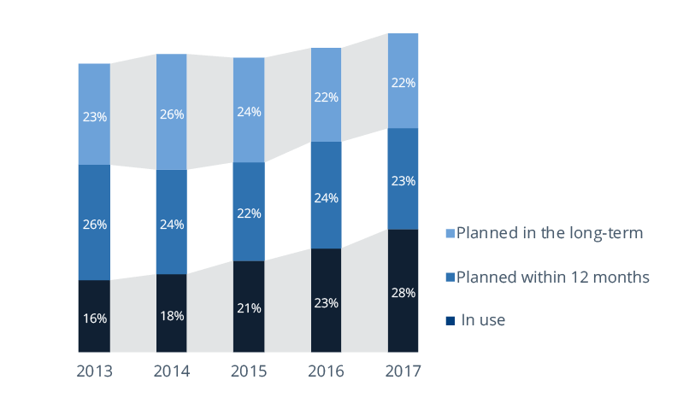

One of the major problems customers face when using mobile devices for information retrieval is the fact that mobile BI is no longer as simple as the pure display of BI content on a mobile device. Moreover, a mobile strategy has to be defined to cope with different suppliers and systems as well as private phones.

Besides attempts to standardize with the same supplier, companies are also concerned that solutions should have robust security features. These points have led many to the conclusion that a proper concept and strategy must be in place before supplying corporate information to mobile devices.

1. ***Benefits of mobile BI:***

* The first major benefit is the ability for end users to access information in their mobile BI system **at any time** and **from any location**. This enables them to get data and analytics in ‘real time’, which **improves their daily operations** and means they can **react more quickly** to a wider range of events.
* The integration of mobile BI functions into operational business processes increases the penetration of BI within organizations and often brings benefits in the form of additional information.
* This **speeds up the decision-making** process by extending information and reducing the time spent searching for relevant information. With this **real-time access to data**,**operational efficiency** is improved and **organizational collaboration** is enforced.
* Overall, mobile BI brings about **greater availability of information**, faster reaction speed and **more efficient working**, as well as **improving internal communication** and**shortening workflows**.
* Finally, with the provision of proper mobile applications to all mobile device users, information can be used by people who previously did not use BI systems. This in turn leads to a **higher BI penetration** rate within companies.

1. ***Mobile BI technology:***

* A variety of mobile devices can be used to display and actively work with information. Smartphones, tablets and wearables from brands such as Apple, Samsung, HTC and BlackBerry are the most common today.
* A significant difference between these types of device is obviously the size of the screen, which also affects mobile BI. For instance, tablets are comparable to small notebook computers, and are typically not subject to the extreme constraints of the small screen of a mobile phone.
* Thus, they offer more space to display content such as dashboards and reports, business data and KPIs compared to the smaller screen of mobile phones. Although BI applications can theoretically run on both tablets and mobile phones, they are not equally well suited to all types of BI. For example, interactive data visualizations require more screen space than displaying KPIs within a table.
* There are various ways to implement content on mobile devices. The most common we see in the marketplace are:
* Provision of PDF reports to a mobile device
* Website (HTML rendering), partly using proprietary technologies (Flash, Silverlight)
* HTML5 site
* Connection of a native application with HTML5 (hybrid application)
* Native application
* In principle, any BI vendor that can create a PDF or render in HTML (and almost all of them can) can say it supports mobile BI. Most mobile devices include a web browser that can access almost any web page to an acceptable degree of quality. The exception here is when proprietary technologies – which require additional software to display – are used.
* In the case mentioned, BI developers must check how their content renders on a mobile device when creating reports and other visualizations. This means designing their application specifically for mobile use. The main advantage of this is its independence from device types (except when using proprietary technologies), since the content can be consumed on all devices.
* Another interesting trend among many software developers is the HTML5 client. BI content is displayed in the browser as previously described, but with several improvements. HTML5 enables Rich Internet Application (RIA) content to be projected across all types of mobile devices without relying on proprietary standards and without having to deal with their disadvantages.
* This technology is favored by software manufacturers, and not just because of its browser and operating system capabilities. The end user also benefits by being able to use it without having to install it. Unlike traditional HTML rendering, clients developed in HTML5 also provide some mobile-optimized navigation controls and functions such as zooming, pinching and double-tapping.
* In addition, HTML5 can be merged with the features of a native mobile application into a so-called “hybrid” form. This generally refers to a web application that can be downloaded as an app and installed on the device, but at its core includes a web viewer. For this reason, hybrids are often hard to distinguish from native apps. This hybrid category essentially supports more of the native features of the mobile device than a pure HTML5 client, but fewer than a native application.
* The “native” application type is the most expensive way for software manufacturers to support mobile BI because the software has to be tailored to the operating system (OS) of the mobile device. Native apps are typically downloaded and installed.
* The advantage of these products lies in their support of device-specific properties, such as the use of cache and navigation controls like “swipe” on the iPhone or iPad. Although the creation of native apps requires effort on the customer and vendor side, they enable interactive and enhanced use of analytics content.
* For instance, device functions such as voice recognition can be coupled with the software’s natural language generation capabilities to query data ad hoc based on speech. Moreover, app developers are able to use sensors such as GPS to guide a customer to an article which is calculated to be potentially relevant to him. The more operational use and interaction with information that is required, the better the mobile OS support has to be.
* In general, the trend in mobile BI apps is veering towards knowledge generation rather than pure content consumption. Analysis and manipulation as well as input options for data are increasingly supported these days. Meanwhile, forecasts based on past data can be statistically calculated and directly reused on mobile devices.
* In our opinion, information should be updated as often as the reader needs it (sometimes even in real time). Especially in operational scenarios, decision-makers often have to react instantly to insights from data or changes in circumstances.
* ***Challenges of Mobile Business Intelligence:***
* Regardless of the delivery option, customers must consider usability. Displaying familiar content in a mobile browser (even as HTML5) does not necessarily mean that it can be used intuitively. Companies and app developers should take great care in designing the user interface to ensure the app’s acceptance, especially in operational scenarios where workers may not be accustomed to using BI
* When implementing a mobile BI solution, security and privacy may pose problems. Companies have to make sure they implement a strong security configuration in order to protect sensitive business and user data. Furthermore, the mobile strategy should be aligned with existing security procedures.
* Mobile devices can easily be hacked, lost or stolen. Using mobile BI may consequently put sensitive or confidential information at greater risk of being breached.
* Due to the limited screen size of mobile devices, the design of mobile BI applications presents new challenges to developers. Each device and browser works differently.
* ***Mobile BI tools:***
* The requirements and expectations of mobile BI are increasing so the [selection](https://bi-survey.com/software-selection-process) of the right product is key to guaranteeing the maximum return on investment.
* Since providers are strongly oriented towards the most popular operating systems, they are also aligning their product portfolios for mobile BI.
* As well as vendors developing mobile BI solutions for their own [BI software](https://bi-survey.com/business-intelligence-software-comparison), there are more and more companies selling platform-independent systems. Most of them are specialist manufacturers who use the BI systems of popular providers such as IBM, SAP or Microsoft to extract information. Data is then integrated, processed and displayed using their own technologies. This type of mobile software is especially suitable for companies that use multiple BI systems.